 | 2023 National Muzzle Loading Championships  Hosted by Perth Muzzle Loading Club | 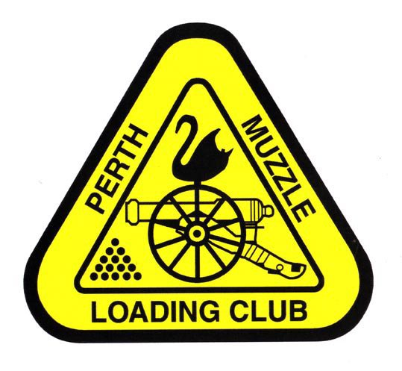

SSAA invite all interested SSAA members to enter the 2023 National Muzzle Loading Championships, to be held from Thursday 6th April to Monday 10th April.

Thursday 6th April Practice day, 8.00am till 4.00pm
Friday 7th April Pistol and Musket
Saturday 8th April Rifle
Sunday 9th April Rifle
Monday 10th April Rifle and BP Ctg Rifle

All competitions will be shot in accordance with the SSAA Muzzle Loading Rule book No 8, November 2018, and the Annex Rules (Specific Black Powder Cartridge Events, 2018).

All nominations will be $7 per event, with the exception of shotgun which will be $10. The maximum adult fee is set at $120, while that for juniors is set at $60.

Nominations to be received no later than Friday 24th March.

YOU MUST BE A CURRENT SSAA MEMBER.
MEMBERSHIP CARDS WILL INSPECTED ON THE DAY.

Awards : Medals will be awarded for the top three positions in all competitions.

The Discipline Delegates meeting will be held at 6pm on Saturday 8th April in the PMLC clubhouse. All delegates attending need an authorisation letter from their State Secretary in writing to the National Discipline Delegate.

Facilities: The canteen will be open each day for lunch/snacks.

Camping: There are a limited number of powered camping and caravan sites available, showers, ablutions.

Location: Perth Muzzle Loading Club
Wanneroo Shooting Complex
720 Perry Road
Pinjar, WA 6078

For further information contact Bob Boyd on 0417 953 257, or by email
at Robertjboyd@bigpond.com

2023 NATIONAL MUZZLE LOADING CHAMPIONSHIPS
7TH APRIL – 10TH APRIL, 2023

At the SSAA Perth Muzzle Loading Club, Wanneroo Shooting Complex

No | Event | Class | Firearm | Are you sharing F/arm & with whom
1 | 25m Precision Revolver (MLAIC) | 1
2 | 25m Timed Revolver | 1
3 | 25m Precision Pistol (MLAIC) | 2
4 | 25m Timed Pistol | 2
5 | 25m Precision Pistol/Revolver | 3
6 | 50m Precision Pistol/Revolver | 3
7 | 25m Flintlock Pistol (Rifled) | Firelock
8 | 25m Flintlock Pistol (Smooth Bore) (MLAIC) | Firelock
9 | 50m Offhand (MLAIC) | 1
10 | 50m Snap | 1
11 | 100m Bench Rest | 1
12 | 100m Prone (MLAIC) | 1
13 | 50m Offhand (MLAIC) | 2
14 | 50m Snap | 2
15 | 100m Bench Rest | 2
16 | 100m X Sticks | 2
17 | 100m Bench Rest | 3
18 | 200m Bench Rest | 3
19 | 50m Offhand (MLAIC) (Firelock) | 4
20 | 50m Kneeling (Firelock) | 4
21 | 100m Prone (MLAIC) (Firelock) | 4
22 | 50m Offhand Musket | Firelock
23 | 50m Offhand Open Musket (MLAIC) | Open
24 | 50m Offhand Vetterli Rifle Agg (MLAIC)
25 | 100m Prone Whitworth Rifle Agg (MLAIC)
26 | 100m 3 Position Agg | 3
27 | Percussion Shotgun (MLAIC) | Trap
28 | Flintlock Shotgun (MLAIC) | Trap
29 | Black Powder Cartridge Rifle 200m Bench Rest | ASSRA
30 | Black Powder Cartridge Rifle 100m Bench Rest | ASSRA
31 | Black Powder Cartridge Rifle 100m Offhand | ASSRA
 | Tony Van Elst Trophy 25m smooth bore | M/lock

Competitor’s Name: ………………………………………………………………………………………. SSAA Number: ……….……………
Email: …………………………………………………………………………………………………………… Tel: ……………………………….

The presentation Dinner will be Monday 10th April at Local Tavern (to be advised) and pay as you go for food & drinks.

NOMINATION FEES: $7.00 per event; Shotgun $10.00 per event. Maximum Fee Adults $120.00; Juniors $60.00.
Number of events entered ……………. at $7.00 event $.......................
Number of shotgun events …………… at $10.00 event $.......................
Total $.......................
Number attending Presentation dinner …………………………. Will you be camping on the range? Yes / No

Payment will be by cash / cheque / bank transfer payable to “Perth Muzzle Loading Club”.
Bank details are: CBA, Morley, BSB No: 06 6132, Account No: 1038 4585 (please identify payment with name and SSAA membership number)
Entries close 1TH April 2023. All entries to be submitted to: PMLC, c/o Bob Boyd, 2 Margaret Place, Heathridge, WA 6027, or Email robertjboyd@bigpond.com

